# Getting started with Kafka

## Install the VM

Running the VM requires 2Gb of RAM and approximately 7Gb of free HD space

Download VirtualBox from <https://www.virtualbox.org>.

Start VirtualBox

Import the VM image by going to File, Import Virtual Appliance and browse to the image file. The VM requires 2Gb of RAM to run.

Start the VM

The VM will boot to a graphical login screen

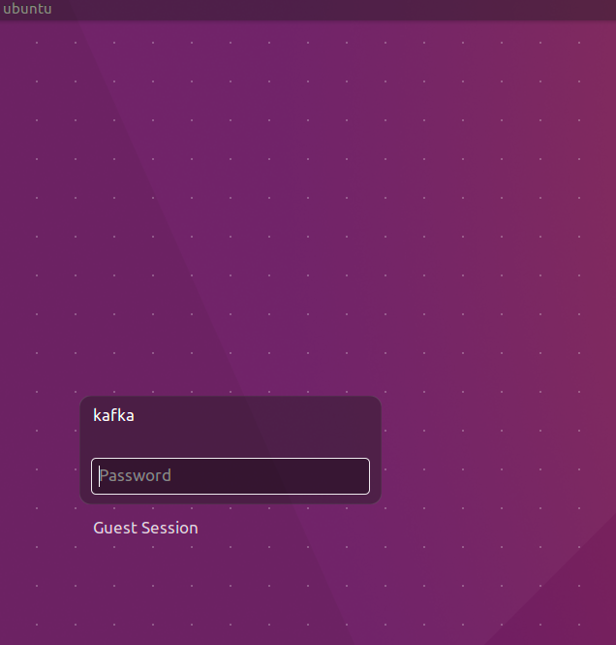

The VM has two users: root and kafka. Both have password Welcome01.

The VM contains:

* Ubuntu 16.04 LTS
* Oracle JDK 8
* Eclipse Neon.2
* Node 7.4
* Zookeeper
* Firefox
* Chrome
* Postman
* confluent-platform-oss-2.11
* kafka-manager 1.3.2.1. When started runs on <http://localhost:9000>
* kafkatool 1.0.1

## Getting to know the VM

Login to the VM: kafka/Welcome01

Start Terminator from the Unity menu

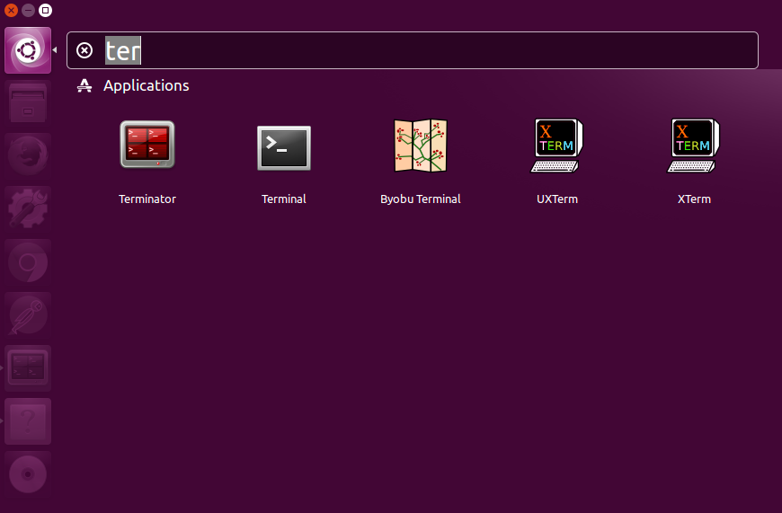

Split the screen horizontally and every screen vertically by right clicking in the window

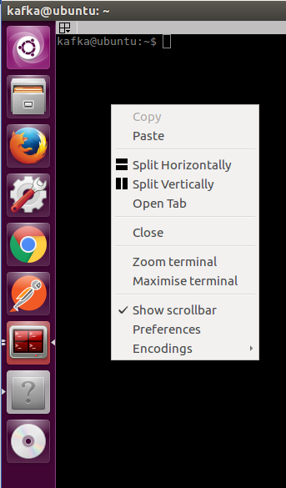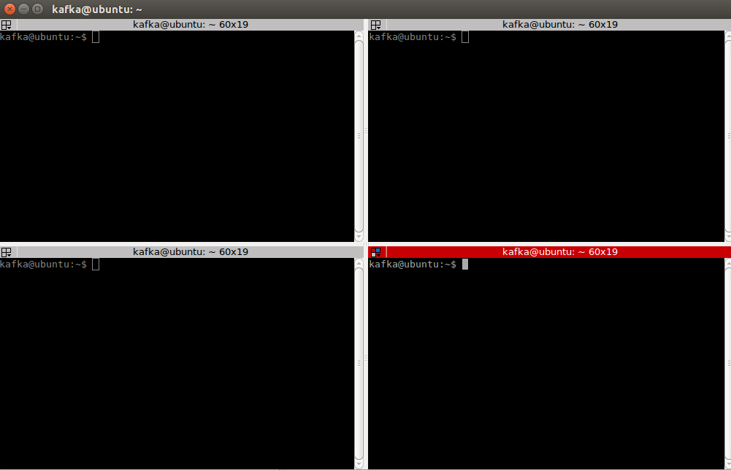

# Getting started with Kafka